**HandsMen Threads: Elevating the Art of Sophistication in Men's Fashion**

**ABSTRACT**

This project presents the implementation of a customized Salesforce CRM solution for HandsMen Threads, a premium men's fashion and tailoring brand. The objective was to streamline business operations, enhance customer engagement, and maintain data integrity across departments.  
The solution involves designing a robust data model featuring five key custom objects: Customer, Order, Product, Inventory, and Marketing Campaign. Business processes were automated using Record-Triggered Flows, Scheduled Flows, Email Alerts, and Apex to handle order confirmations, loyalty status updates, and proactive stock alerts.  
To ensure clean and reliable data, validation rules were established, and a role-based security model was implemented for the Sales, Inventory, and Marketing teams. The solution also includes a scheduled batch job using Apex to update low stock quantities.  
This end-to-end CRM implementation improves customer experience through personalized communication, ensures operational efficiency with automation, and lays a scalable foundation for future business growth using the Salesforce Platform.

**OBJECTIVE**

The main objective of this project is to develop and implement a customized Salesforce CRM solution for HandsMen Threads to streamline core business operations, maintain data integrity, and enhance customer satisfaction.

By building a centralized system to manage customers, orders, products, inventory, and marketing campaigns, the project aims to:

* Automate key processes such as order confirmations, loyalty status updates, and stock alerts.
* Ensure accurate and consistent data entry using validation rules.
* Enable real-time visibility of inventory and customer interactions.
* Improve internal team coordination through role-based access control.
* Deliver personalized customer experiences through targeted communication and loyalty programs.

**TECHNOLOGY DESCRIPTION**

**Salesforce:**

Salesforce is a cloud-based Customer Relationship Management (CRM) platform that helps businesses manage customer data, automate processes, and improve service, marketing, and sales operations. It provides point-and-click tools as well as programmatic capabilities (like Apex and Flows) to build custom business solutions.

**Custom Objects:**

Objects in Salesforce are like tables in a database. Custom Objects are created to store specific data. Examples:

* Customer__c - Stores customer info
* Product__c - Stores product details
* Order__c - Stores orders

**Tabs:**

Tabs are used to display object data in the Salesforce UI. For example, a tab for Product__c allows users to easily view and manage products.

**Custom App:**

An App in Salesforce is a collection of tabs grouped together for a specific business purpose.

**Profiles:**

Profiles define what a user can see, do, and edit in Salesforce. They control object permissions, field access, and more

**Roles:**

Roles control data visibility in Salesforce's role hierarchy. They are used for sharing settings and reporting.

**Permission Sets:**

Permission Sets grant additional permissions to users without changing their profile.

**Validation Rules:**

Validation Rules ensure data entered meets business criteria.

Examples:

* Email must contain @gmail.com
* Stock quantity cannot be negative

**Email Templates:**

Predefined formats for sending emails to customers or users. For example, an "Order Confirmation" template.

**Email Alerts:**

Actions in Flows or Workflow Rules that send emails using predefined templates. For example, when a loyalty level changes, an email is sent to the customer.

**Flows:**

Flows automate business logic without code. They can create, update, or send notifications. For example, a flow triggers email alerts on new order creation.

**Apex:**

Apex is Salesforce's object-oriented programming language allowing developers to write custom logic. Example triggers include calculating order totals and reducing inventory stock.

**DETAILED EXECUTION OF PROJECT PHASES**

**Create Developer org:**

* Created a Salesforce Developer Org via <https://www.salesforce.com/form/developer-signup/?d=pb>.
* Verified account and accessed Salesforce Setup.

**Custom Object Creation**

Created five custom objects for business-critical data:

* HandsMen Customer: Stores customer info like email, phone, loyalty status.
* HandsMen Product: Stores product catalog details such as SKU, price, and stock.
* HandsMen Order: Stores customer orders, quantity, and status.
* Inventory: Tracks stock quantity and warehouse location.
* Marketing Campaign: Manages promotional campaigns and scheduling.

**Creating the Lightning App**

* Created a custom Lightning App named "HandsMen Threads".
* Included relevant tabs: Customers, Orders, Products, Inventory, Campaigns, Reports.
* Assigned app visibility to the System Administrator profile.

**Validation Rules**

* **Order Object**: Prevent saving if Total_Amount__c ≤ 0; error message: "Please Enter Correct Amount".
* **Customer Object**: Email must contain @gmail.com; error message: "Please fill Correct Gmail".

**User Role & Profile Setup**

* Cloned Standard User profile to "Platform 1" and granted access to custom objects.
* Created roles for departments such as Sales Manager, Inventory Manager, Marketing Team.

**User Creation**

Created users and assigned appropriate roles and profiles:

* Niklaus Mikaelson assigned Sales role.
* Kol Mikaelson assigned Inventory role.

**Email Templates & Alerts**

Created three email templates:

Order Confirmation (sent on order status = Confirmed).

Low Stock Alert (sent when inventory < 5 units).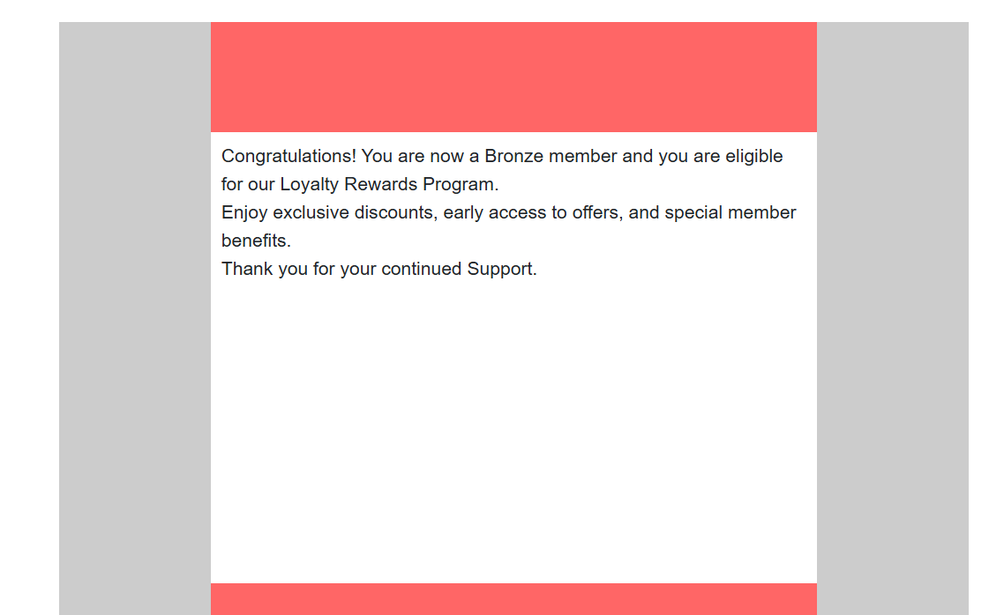

Loyalty Program Email (sent on loyalty status changes).

Email Alerts linked to corresponding flows.

**Flow Implementations**

1. Order Confirmation Flow: Triggered when order status updates to Confirmed; sends confirmation email to customer.

1. Stock Alert Flow: Triggered when inventory drops below 5; sends alert to Inventory Manager.

1. Scheduled Loyalty Update Flow: Runs daily; updates customers’ loyalty status based on purchases.

**Apex Triggers**

* Order Total Trigger: Calculates order total price automatically.
* Stock Deduction Trigger: Deducts inventory stock when order placed.
* Loyalty Status Trigger: Updates customer loyalty status based on purchase history.

**PROJECT EXPLANATION WITH REAL-WORLD EXAMPLE**

**Customer Registration**

* Customer Tumbali Jyotsna registers via store or website.
* A new record with valid email created in Customer object.
* Validation ensures proper format.

**Product Setup**

* Products can be added such as Shirts and Jeans added in Product object with stock quantities.
* Product also has certain price and other details included.

**Order Placement**

* Jyotsna orders 100 Trousers at $7 each and order record created.
* Apex trigger calculates Total_Amount__c = 2 × 500 = ₹1000.

**Inventory Update**

* Shirt stock automatically reduced by 100 units.
* Validation prevents negative stock amount automatically.

**Loyalty Program**

* Jyotsna’s purchases valued at ₹1000 trigger loyalty status updates from Bronze to Silver.
* Based on values:

<500 – Silver

<1000 – Bronze

1000 – Gold

**Email Notifications**

Customer receives order confirmation and loyalty status update emails via triggered flows.

**Users and Roles**

* Niklaus Mikaelson assigned Sales Role with Platform 1 profile.
* Kol Mikaelson assigned Inventory Role with Platform 1 profile.

**SCREENSHOTS**

**Fig : Custom App for HandsMen Thread**

**Fig : Customer Creation**

**Fig : Inventory Creation**

**Fig : Product Creation**

**Fig : Order Confirmation Email**

**Fig : Loyality Program Email**

**Fig : Low Coast Email**

**Fig : Order Confirmation**

**CONCLUSION**

The HandsMen Threads CRM solution, built on the Salesforce platform, effectively streamlines key business functions such as customer management, product cataloging, order processing, inventory tracking, and loyalty program automation.

By leveraging Salesforce features including Custom Objects, Flows, Validation Rules, Email Alerts, and Apex programming, the system ensures:

• Operational efficiency through automation of routine tasks.  
• High data accuracy with enforced validation rules.  
• Enhanced customer experience through timely and personalized communication.

The implementation of role-based access control ensures that teams have appropriate visibility and functionality, reducing errors and improving coordination. This CRM foundation supports scalable growth and positions HandsMen Threads for continued success in the premium fashion industry.

**FUTURE SCOPE :-**

To further enhance the functionality and scalability of the HandsMen Threads CRM solution, the following future enhancements are proposed:

1. **Customer Portal Integration**  
   Develop a customer community portal to enable customers to track their orders, view loyalty status, and manage personal information seamlessly.
2. **Mobile Application using Salesforce Mobile SDK**  
   Introduce a mobile app for internal teams, allowing sales and inventory staff to manage orders, view stock levels, and access customer details on the go.
3. **Reports and Dashboards**  
   Design real-time, interactive dashboards and analytical reports to assist management in making data-driven decisions.
4. **AI-Powered Recommendations (Salesforce Einstein)**  
   Leverage Salesforce Einstein to analyze customer behavior and provide personalized product recommendations, improving upselling and cross-selling opportunities.
5. **WhatsApp and SMS Integration**  
   Integrate WhatsApp and SMS communication channels to send real-time notifications for order confirmations, delivery updates, and loyalty program changes.